./

|  |  |  |  |  |  |
| --- | --- | --- | --- | --- | --- |
| **Ver.Rel. No.** | **Release Date** | **Prepared. By** | **Reviewed By** | **Approved By** | **Remarks/Revision Details** |
|  | 20/2/2022 | Bharat K |  |  |  |
|  |  |  |  |  |  |
|  |  |  |  |  |  |
|  |  |  |  |  |  |
|  |  |  |  |  |  |

**Document History**

**Table of Contents**

|  |  |  |
| --- | --- | --- |
| **Chapter No** | Tittle | **Page No** |
| **1.** | **Requirements and Analysis**   1. Empathize & research 2. High-Level Requirement 3. Low-Level Requirement 4. SWOT Analysis 5. 5W 1H | **2** |
| **2.** | **Design**   1. Block Diagram 2. Structural diagram | **3** |
| **3.** | **Implement** |  |
|  |  |  |
| **8** | **Summary** | **4** |

**Case Study of Digital Alarm Clock**

**1.Empathize & research:**

The system that is anticipated to be built consists of a 6 DIGIT clock including hour, minute and second using a very cheap devices that covers a very favorable place. The design consists of all the features that a digital clock should consist and as the design is synchronous the overall delay is negligible.

**Analysis:**

**3 months to 5 months**

1. **High-Level Requirement:**

|  |  |
| --- | --- |
| **ID** | **Decryption** |
| HR01 | Signal Alarm |
| HR02 | Temperature measuring |

1. **Low-Level Requirement:**

|  |  |
| --- | --- |
| **ID** | **Description** |
| LR01 | EEG |
| LR02 | Electrodes |
| LR03 | Clock requirements |
| LR04 | Digital requirements |

1. **SWOT Analysis:**
2. **5W 1H:**

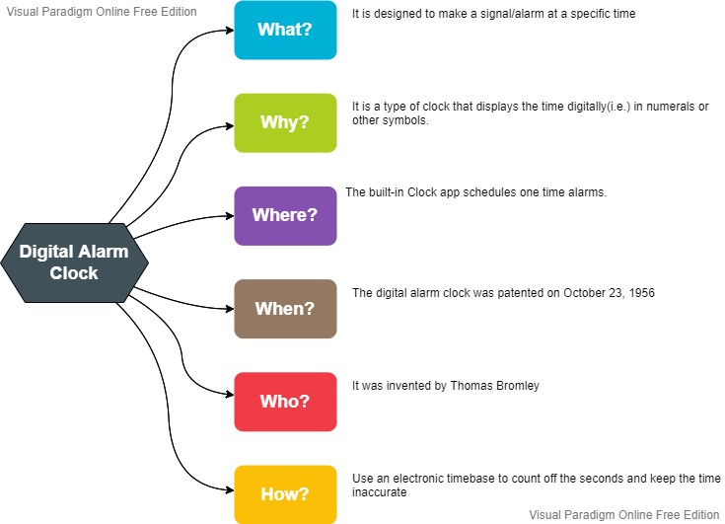

**2.Design:**

1. **Block Diagrams:**

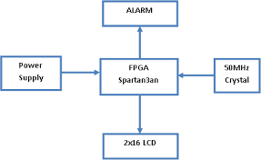

1. **Structural Diagram:**

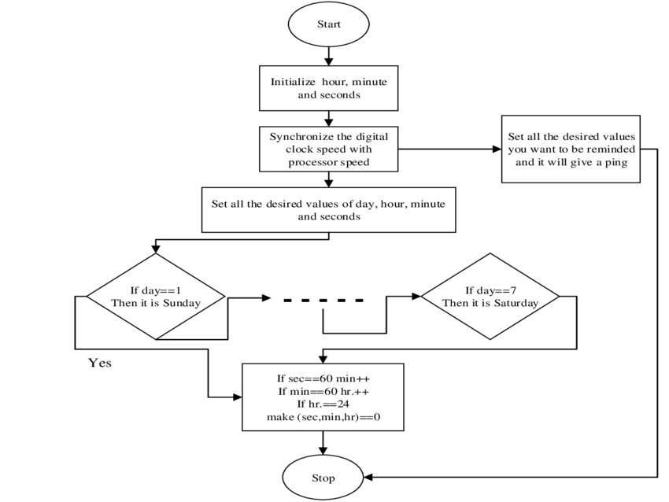

**3.Summary:**

Digital alarm clock is used in many purposes.

A digital clock is an alternative to a traditional analogue clock.

This type of clock shows numbers to display the time in a digital format.

It is designed to alert an individual or group of individuals at a specified time.

**4.References:**

1.Thomas L. Floyd**, "Digital Fundamentals",** Seventh Edition, Prentice-Hall International, Inc., 2000.

2. Donald D. GIVONE, **"Digital Principles and Designs",** McGraw- Hill 2003.

3. Victor P. Nelson, H. Try Nagle, Bill D. Carroll, and J. David Irwin**, "Digital Logic Circuit Analysis & Design"**